Electronic Vehicle Request Form Instructions
For your convenience, every effort was made to have the electronic request form be as close to the printed form as possible.
If you still have printed forms, you may continue to use them until your supply is exhausted.
Filling out the Form:
Field 1: Type of Vehicle: This is a drop-down field. Click on the grey arrow at the right of the field to populate the
drop-down list. Then click on your choice of vehicle. If you choose “Other”, please explain in Field 9 – Purpose of Trip.
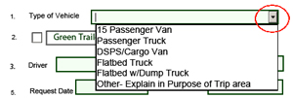

Field 2: If a trailer is needed, please click on one of the options to place a checkmark. Click again to remove the checkmark.
Fields 3-4 and 6 - 9: These are user-populated fields. Type in the information as requested.
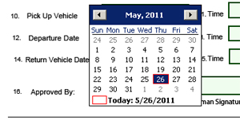
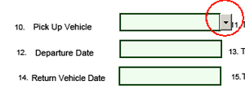
Fields 5, 10, 12 & 14: These are date fields. You have the choice of manually typing in the dates, or using the drop-down calendar feature. Click in one of these fields to reveal the drop-down button. Clicking on the button will reveal the calendar. The “Time” fields are also drop-down fields.

Fields 11, 13 & 15: Please enter the nearest times of pick-up, departure and return.
Field 16: Approved By. Type in a name here. Or, if you prefer to print the form and send it in, you may have it manually signed.
Please mark your appropriate licensing, and type your name in the “Driver’s Signature” area. By your ‘virtual’ signature here, you are certifying you “have not been issued more than three moving violations or been responsible for three accidents or a combination of three of the above during a period of the last three years, and that the person named in the "Approved By" field above has approved this request.”
Click the “Submit by Email” button. You may receive a pop-up. If you are using Microsoft Outlook, choose the “Desktop Email Application” button. Your request will be attached to an email that is ready to be sent. You will find a copy of the request in your sent mail. If you are using internet email, you’ll need to save the form first, and then attach it to an email.
You may print the form for your records, or save it to a file on your computer. Once you have finished emailing, printing or saving the form, you can click on the “Reset Form” button to clear your entries
Please feel free to call Michael Carroll at x3283 if you have any questions.

