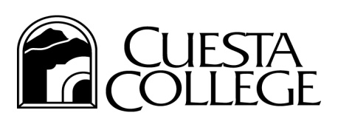 |  | Human Resources
San Luis Obispo County Community College District

MEMORANDUM
TO: | Short Year Calendar Employee
FROM: | Human Resources
DATE: | May 7, 2021
SUBJECT: | Notification of Reasonable Assurance – Short Year Calendar Employees

Cuesta College hereby notifies you that you have Reasonable Assurance of returning to work in your position in the 2021 - 2022 fiscal year.

You may file an unemployment insurance claim at the conclusion of the current school year. Your entitlement to unemployment benefits will be determined by the Employment Development Department and not by Cuesta College.

If you are not offered an opportunity to perform services in the next academic term, you may be entitled to unemployment insurance benefits retroactive to the date you filed an initial claim, if you file a claim for the benefits within 30 days after the start of the next academic year/term and if you are otherwise eligible.

This letter is the only official and authorized notification on which you should rely when determining your employment status for the next academic year or term.

