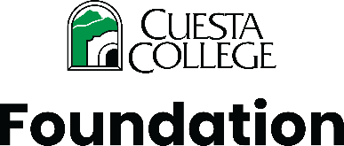

Alumni Committee Meeting Agenda

Thursday, May 28 | 4 p.m.
Zoom Meeting Link: https://cuesta-edu.zoom.us/j/81029460322
Committee Chair: Janice Fong Wolf
Foundation Staff: Katie Osman, Executive Director; Sarah Fessenden, Foundation Programs Coordinator
I. Call to Order
II. Review of Spring Alumni Engagement Efforts (15 minutes) – Sarah
- Grad Cap Decorating Event
- Transfer Celebration
- Rodeo Benefit
- Commencement outreach
- Discussion of spring engagement goals and outcomes
Action: No action required.
III. Selection of 2026 Honored Alumni (35 minutes) - Janice
- Committee discussion
- Consideration and selection of 2026 Honored Alumni
Action: Possible motion to approve 2026 Honored Alumni recipient(s).
IV. Foundation Updates (10 minutes) - Katie
- Planning underway for Fall 2026 alumni stewardship and recognition event at the new SLO Campus Center
V. Recognition of Janice Fong Wolf (5 minutes) - Katie
- Acknowledgment of service and leadership on the Alumni Committee
VI. Adjournment

